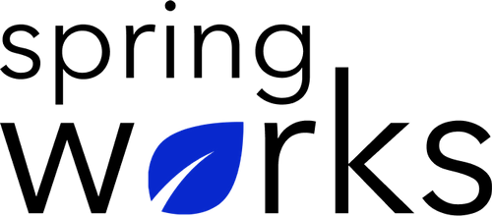
Free Template – HR Effectiveness Survey

Find out how well your HR team support your staff

HR Effectiveness Survey questions measure employees’ overall satisfaction with HR team, along with their opinion of HR’s policies.

Using this template, you can gauge your HR team's effectiveness in communicating with employees, resolving staff issues, managing employee activities, etc. Copy this template to your Google Drive and customize it for your organization.

Communication (to be added as review instructions):

All answers you give will be treated with the utmost sensitivity, and the information will not be used for any other purpose apart from planning and improvement. Please answer this quick survey by <HOUR OF THE DAY> on <DATE>.

Demographic Information:

The following information is requested so that meaningful analysis and comparisons of group results can be made. Please check the circle corresponding to your answer.

Q: Your Gender:

- Male
- Female

Q: Your Department:

- Marketing
- Operations
- Tech
- Accounting
- HR

Q: Company Service:

- Under 1 Year
- 1-2 Year
- 3-5 Year
- 6-10 Year
- 10-15 Year
HR Effectiveness Questionnaire

To answer clearly what you think or feel about each item, please follow these steps:

- Read each item fully before you start to mark your answer.
- Pick the one answer which most nearly says what you think or how you feel.
- While completing the questions, be sure to read the special instructions which are included.

Q: How would you rate the HR team overall?

- 1
- 2
- 3
- 4
- 5

Q: How approachable do you find HR when seeking information, advice or support as an employee?

0 | 1 | 2 | 3 | 4 | 5 | 6 | 7 | 8 | 9 | 10

Q: Do you believe HR adequately communicates with staff about policy changes?

- Yes
- No
- Not sure
- I don't know

Q: Do you believe HR adequately supports staff with work-related problems?

- Yes
- No
- Not sure
- I don't know

Q: HR treats you with courtesy and respect

- Strongly agree
- Agree
- Neutral
- Disagree
- Strongly disagree

Q: HR provides information when you need it and/or in a timely manner.

- Strongly agree
- Agree
- Neutral
- Disagree
- Strongly disagree

Q: Does HR reply to your emails?

- Yes
- No

Q: HR has been instrumental in improving work environment

- Strongly agree
- Agree
- Neutral
- Disagree
- Strongly disagree

Q: Our HR team values and promotes diversity

- Strongly agree
- Agree
- Neutral
- Disagree
- Strongly disagree

Q: Do you have any other feedback about the HR team?

Thank you for sharing your opinions.

